Indian Oil Corporation Retail Outlet Solarisation Subsidy Scheme

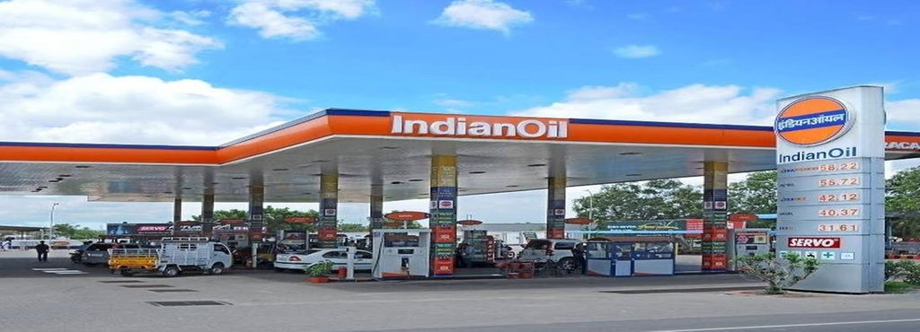
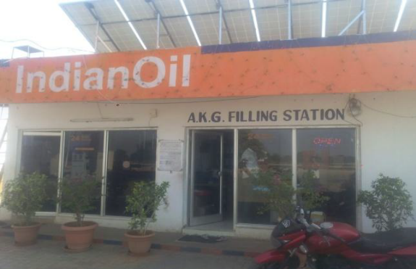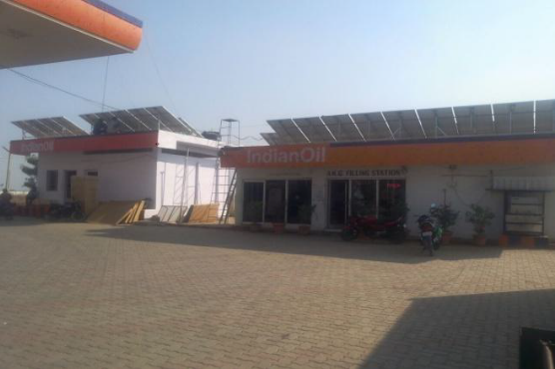
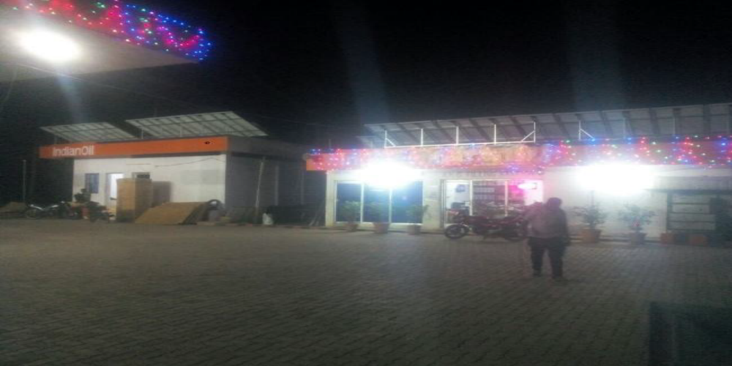


Indian Oil Corporation Retail Outlet Solarisation Subsidy Scheme

Specification and Price Details for Solar Off-Grid Power System
System Capacity | Solar Panel Capacity | Inverter Capacity in KVA | Battery Specification | No of Hrs Back Up | Total Cost of System | % of Subsidy for the System Capacity
3 | 3000Wp | 3 | 48V/200Ah | 2Hrs | ₹ 3,35,000 | 55
5 | 5000Wp | 5 | 96V/150Ah | 2Hrs | ₹ 4,35,000 | 60
7 | 7000Wp | 10 | 120V/150Ah | 2Hrs | ₹ 6,30,000 | 60
10 | 10000Wp | 10 | 120V/100Ah | 1Hrs | ₹ 7,75,000 | 65
15 | 15000WP | 15 | 240V/100Ah | 1Hrs | ₹ 11,60,000 | 65

Specification and Price Details for Solar On-Grid Power System
System Capacity | Solar Panel Specification | Inverter Capacity in KVA | Total Cost of System | % of Subsidy for the System Capacity
3 | 3000Wp | 3 | ₹ 2,47,500.00 | 55
5 | 5000Wp | 5 | ₹ 3,47,500.00 | 60
7 | 7000Wp | 10 | ₹ 4,97,500.00 | 60
10 | 10000Wp | 10 | ₹ 6,42,500.00 | 65
15 | 15000WP | 15 | ₹ 9,60,000.00 | 65

Guarantee and Warranty and Maintenance detail
Solar Panel | 90% Efficiency at the End of 10Years and 80% Efficiency at the End of 25th year
Inverter | 5Years
Battery | 5Years
Any other | BOS 5Years

Payment & Delivery Terms and conditions:
- 25% to be paid along with the PO
- 65% to be paid at the material ready to dispatch.
- 10% to be paid after completion of installation and commissioning.
- Delivery will be made 2weeks from the date of PO.
- Installation and commissioning will be completed within one week of material reaching the site.

:
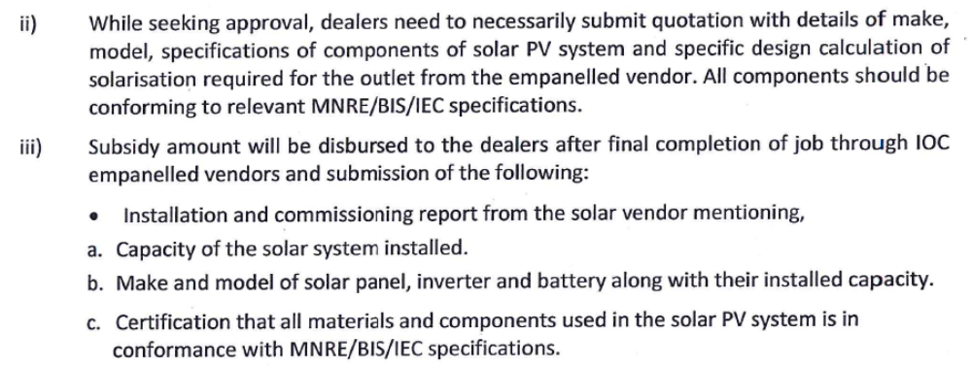
Submission of Documents:
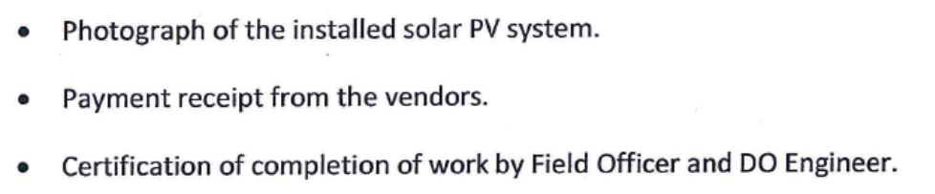

Contact Details
GREENTEK INDIA PVT LTD
Plot No :8, Lepakshi Colony, West Marredpally,
Secunderabad-500026.
Mobile:9951067111,9948663079,9848054435
E-Mail:info@greentekindia.co.in

